R & D Challenge

1.Install Docker
-> I have launched EC2 instance
-> Connected to instance
-> Installed docker by below command
sudo yum install docker
->I have started and checked the status of docker whether it is running or not
sudo systemctl start docker
sudo systemctl status docker
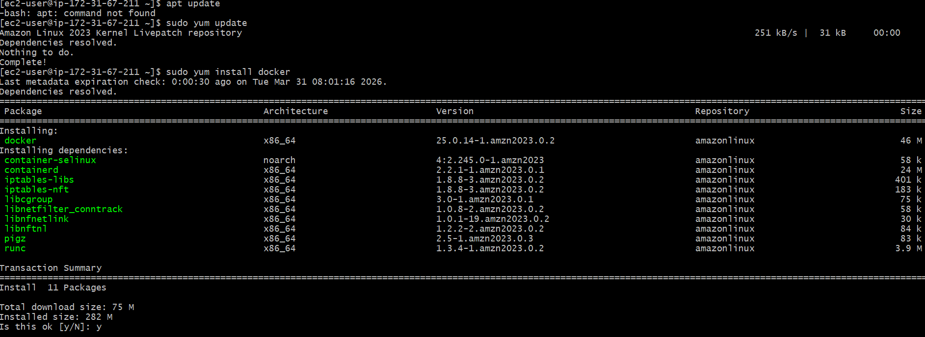
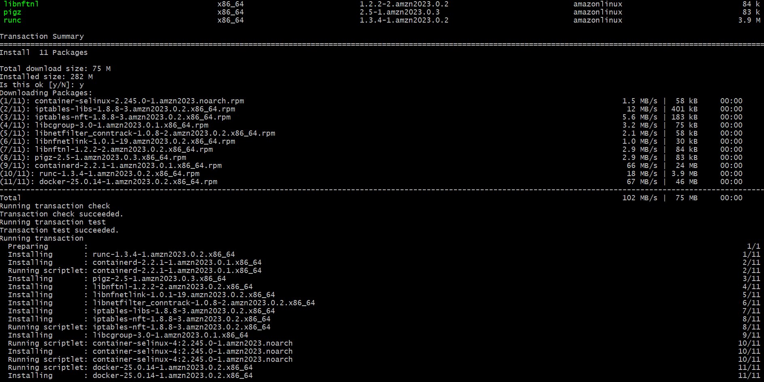
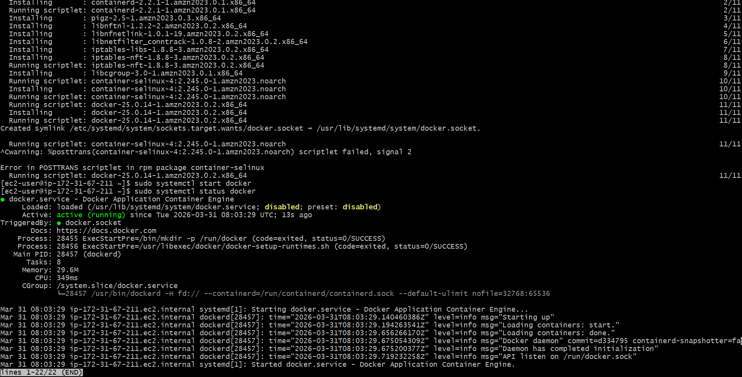

2.Install Apache
Sudo yum install httpd – Install Apache
Sudo systemctl start httpd
Sudo systemctl enable httpd
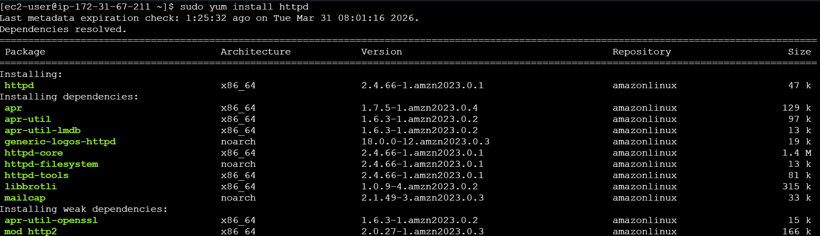
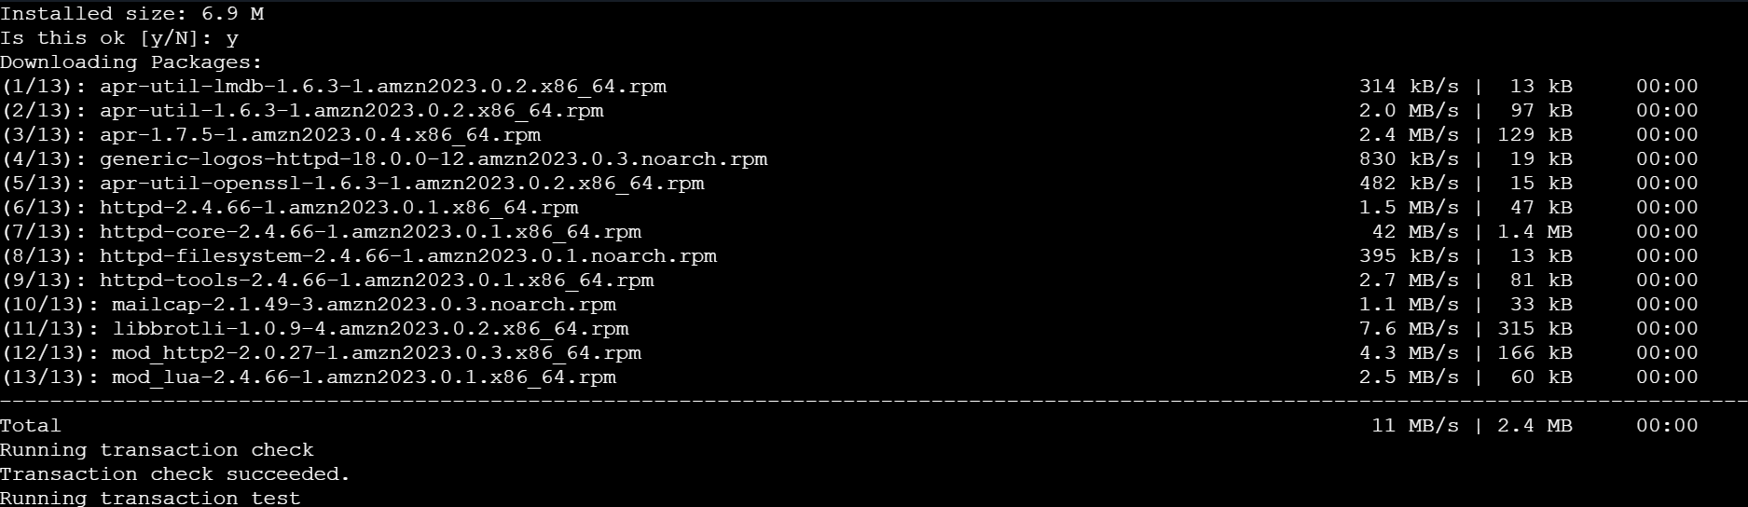
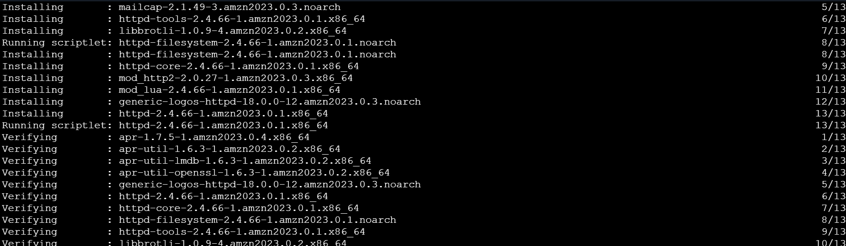

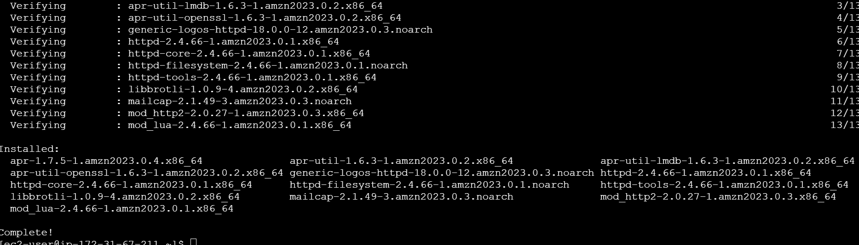

- I have changed the port to 8081
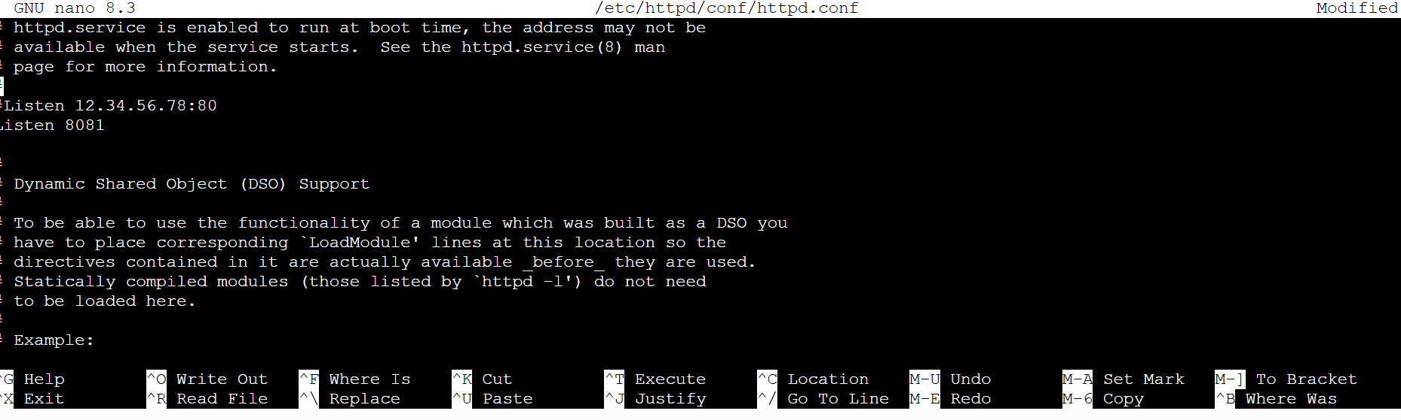

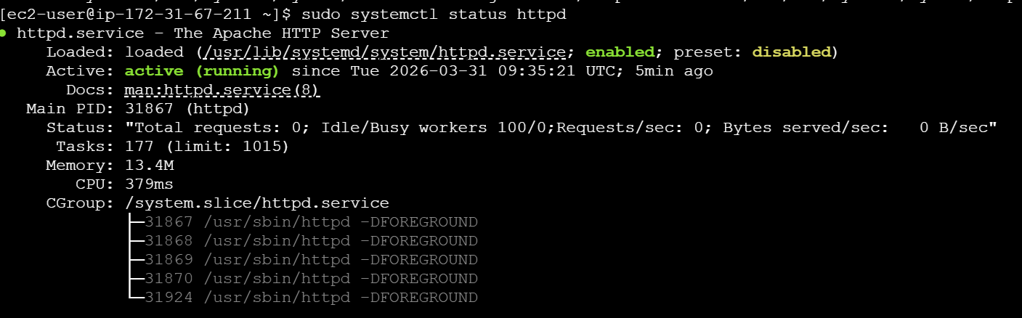

3.Install Jenkins

- First I have installed java
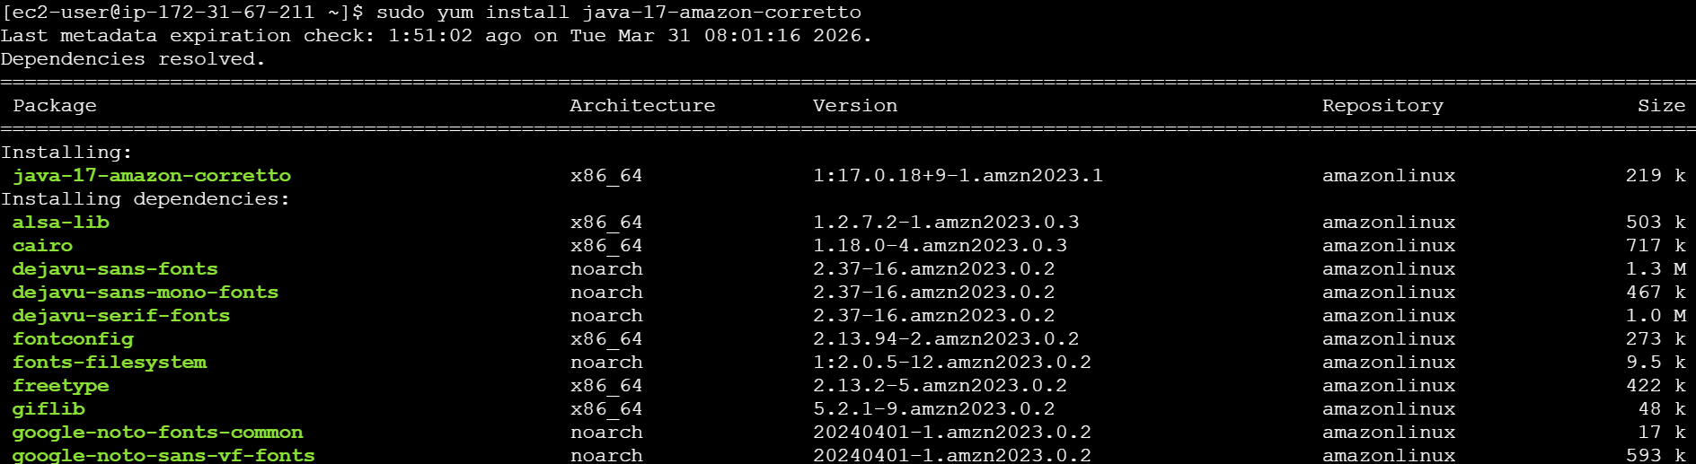

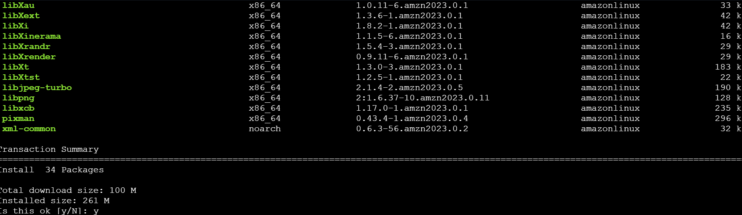
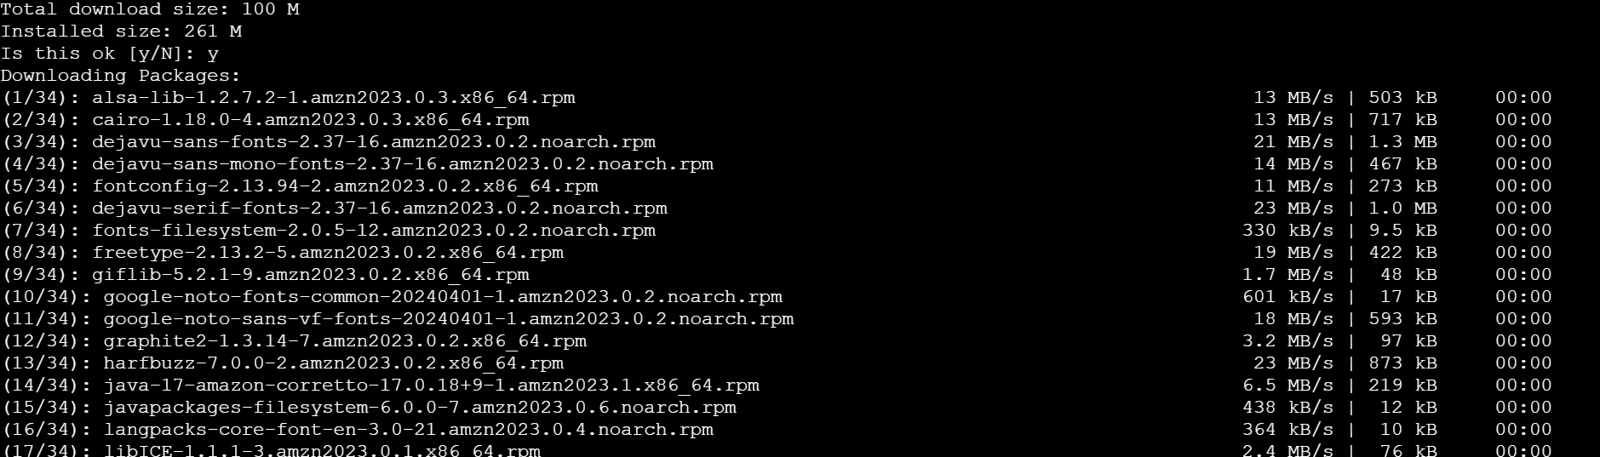
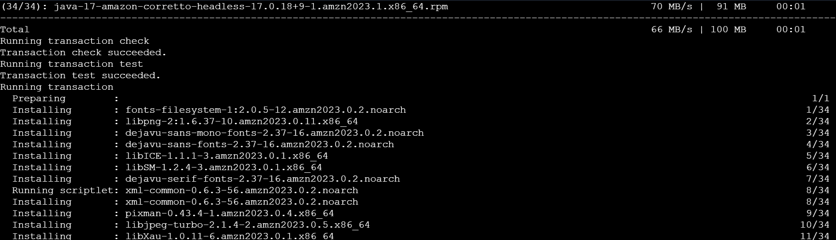
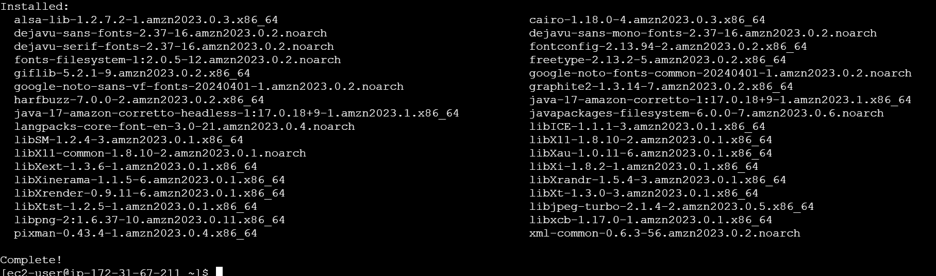
- Added Jenkins repositories
- Imported Jenkins key
- Installed Jenkins
- Configured security group, I have added port number 8080

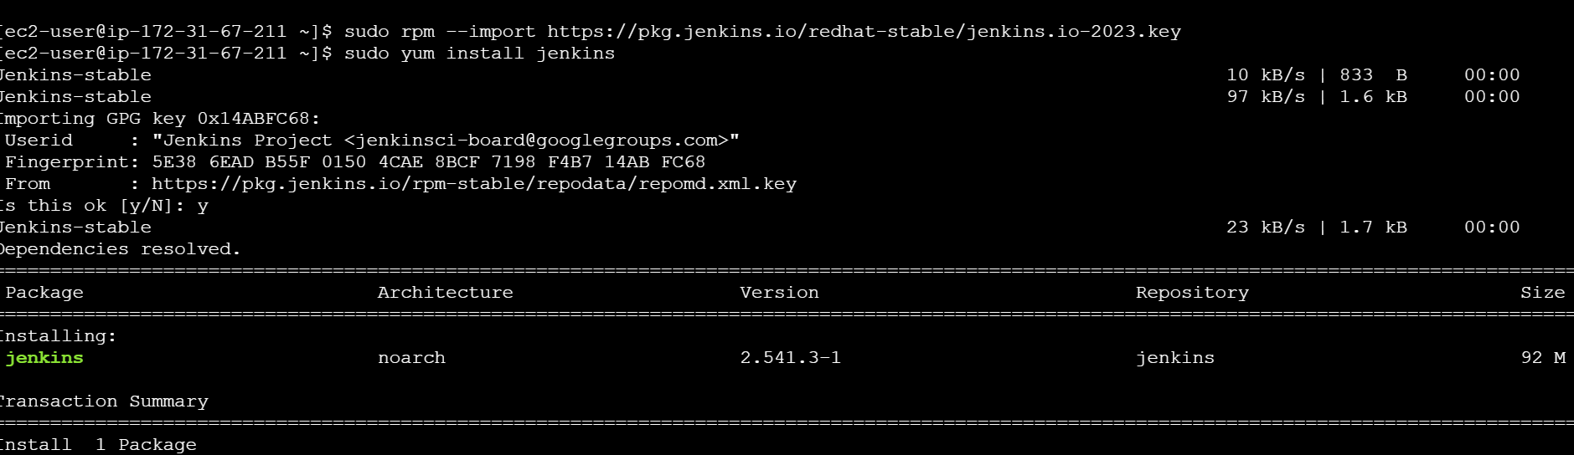
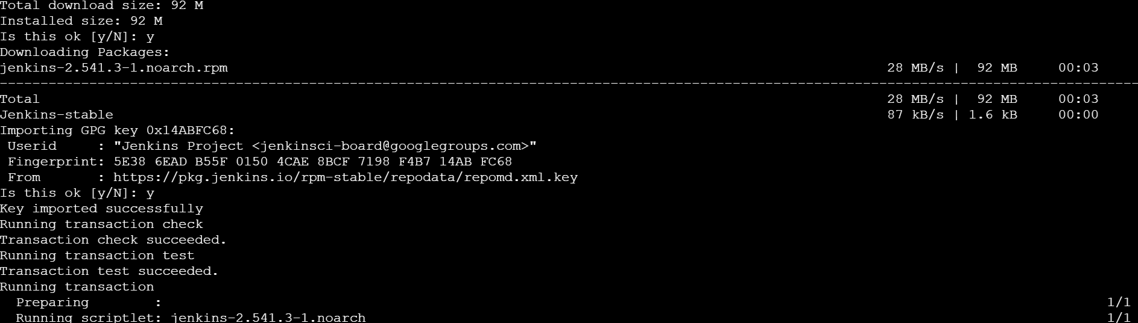
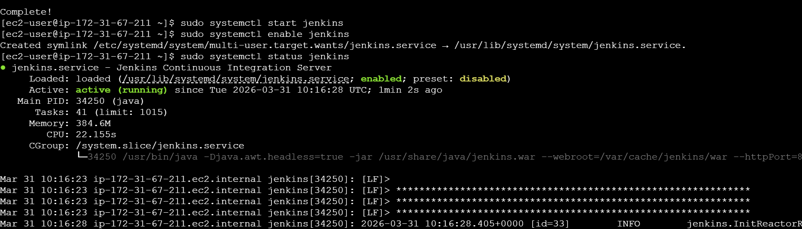
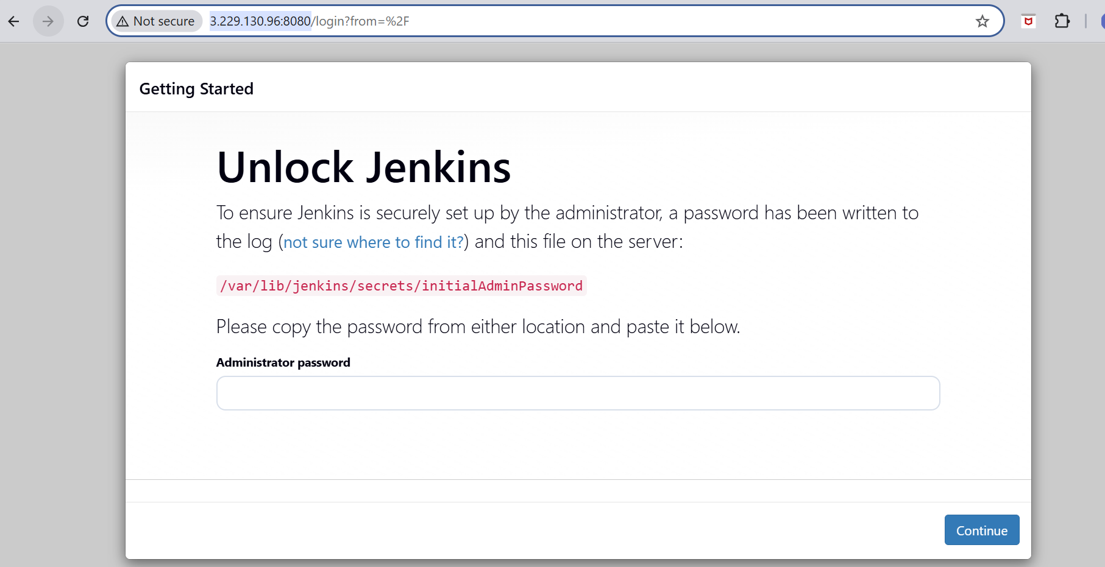

4.Install Nginx

- I have installed nginx
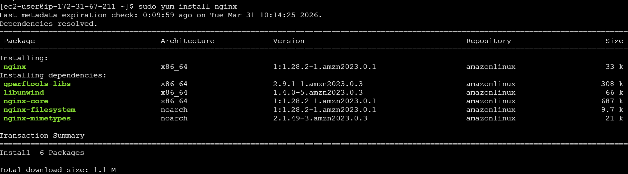
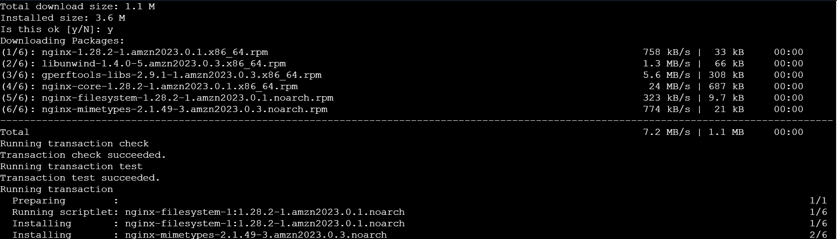
- Started nginx service
- I have checked the status whether it is active or running
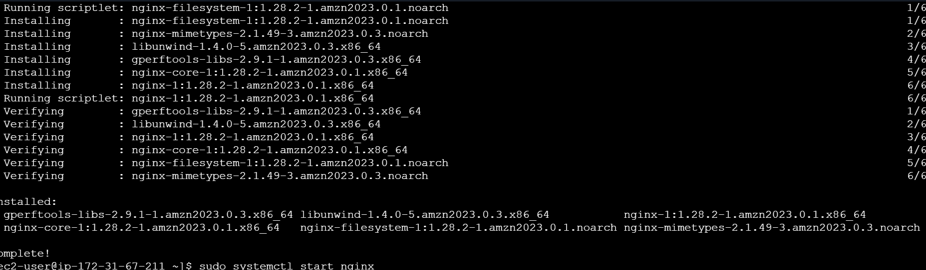

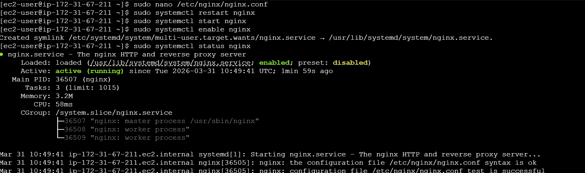
- I gave the port number 81

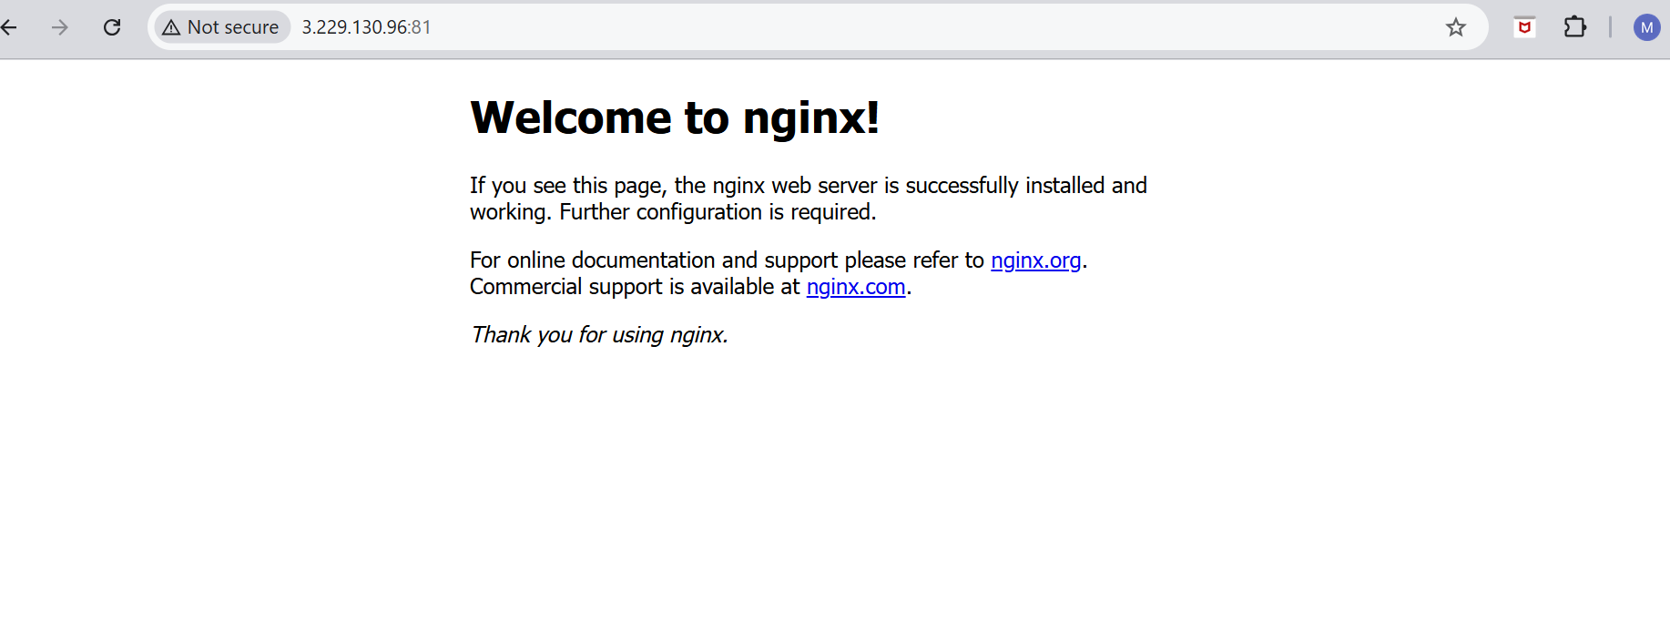

5.Install Apache Tomcat
- First I have downloaded the package from browser and installed by wget command
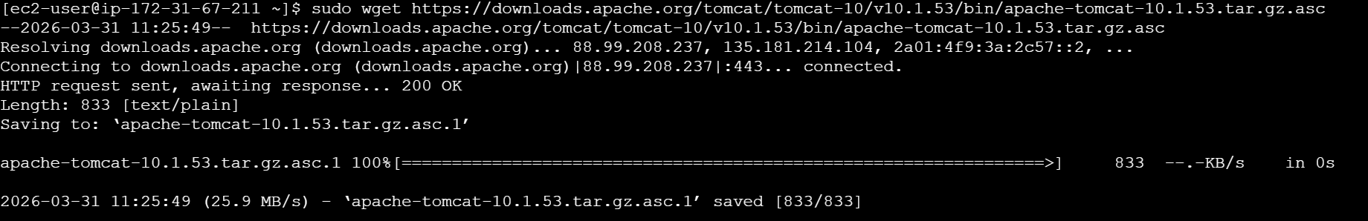

- I have extracted the downloaded tar file.
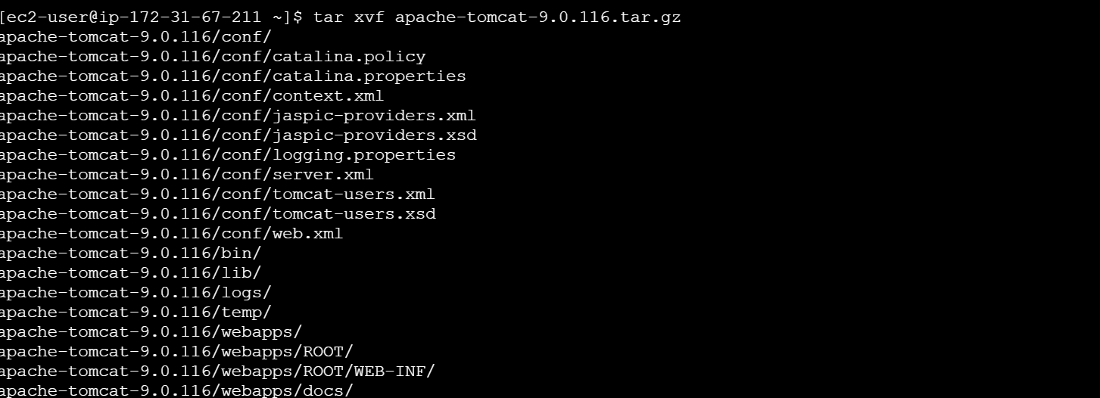
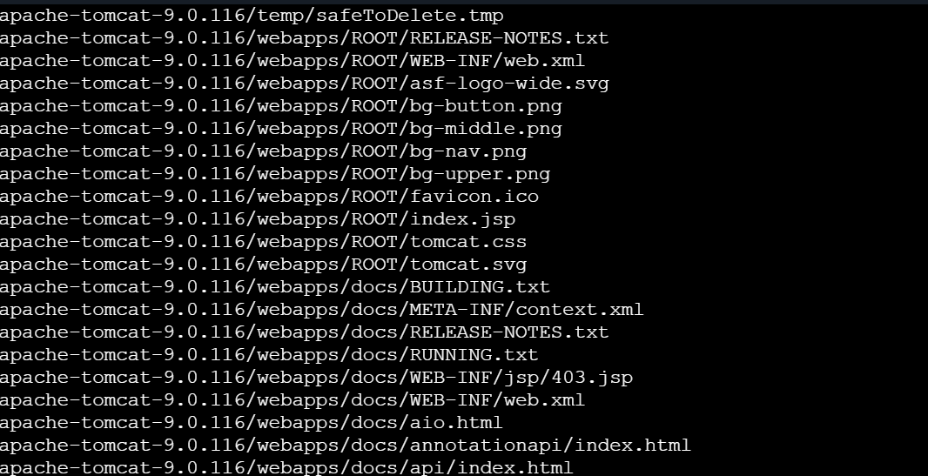
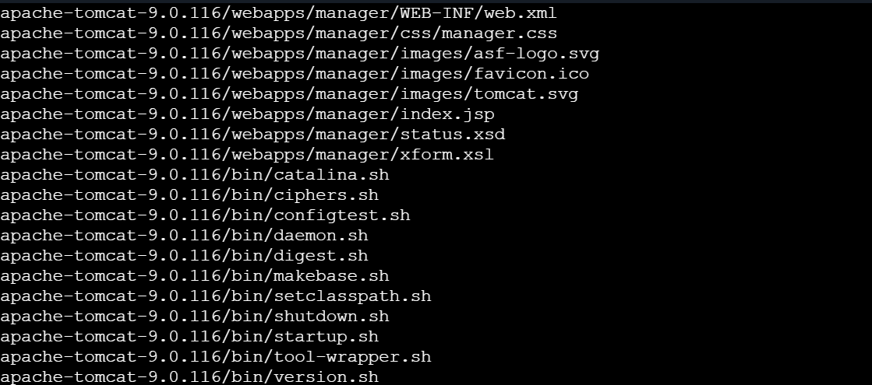

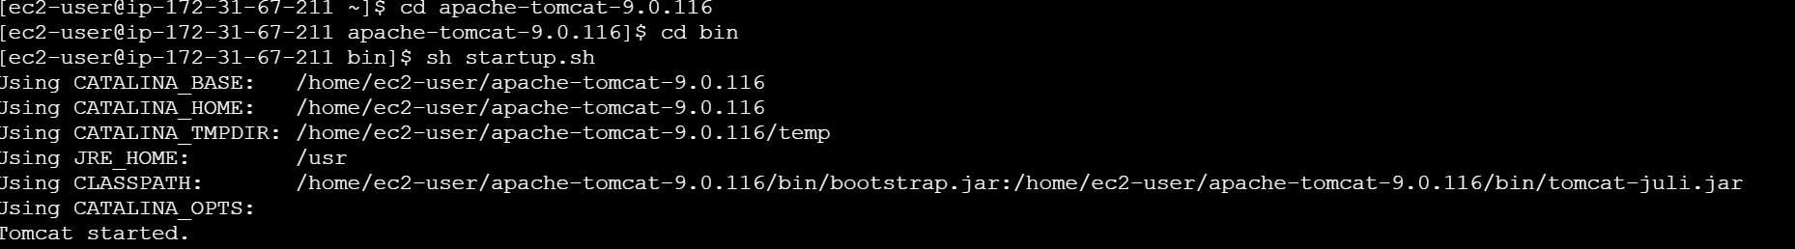
- I gave the port number as 8081
